COMPUTER NETWORKS PROJECT REPORT

1. Title Page
Project Title: Design and Simulation of a Cloud Networks
Course: Computer Networks
Group Members:
- [Hadia Habib , Ayesha Saaid] – Roll No: 12,25
Instructor: [Pro.Bilal Ahmed Raza]
Department & University: BS(DS)6th
- Submission Date: 4th December, 2025

2. Abstract
This project presents the design and simulation of a hybrid cloud-based network using Cisco Packet Tracer. The purpose of the project is to demonstrate the integration of local infrastructure with cloud connectivity. The topology includes cloud gateways, a DSL modem, local servers, access points, and end-user devices. The simulation confirms successful communication between all devices, validating the reliability and scalability of the network design.

3. Introduction
Cloud computing has transformed modern networking by enabling organizations to combine on-premises resources with cloud services. Hybrid cloud networks allow secure access to internal services while providing scalability through cloud platforms. This project simulates a hybrid network where local servers and PCs communicate with cloud resources using Cisco Packet Tracer.

4. Objectives
Design a functional hybrid cloud network topology.
Configure IP addressing, servers, and wireless access points.
Test LAN, WLAN, and cloud connectivity using simulation tools.
Understand cloud–LAN communication flows.

5. Tools & Software Used
Tool / Software | Version | Purpose
Cisco Packet Tracer | 8.x | Network design & simulation
Cloud Simulation (Cluo-FT) | Default | Virtual cloud service provider
Local Server (Server-FT) | Default | DHCP, DNS, HTTP services
Access Points | Default | Wireless connectivity

6. Network Topology
Topology Type: Hybrid (Star + Extended Star)
Logical Flow:
Cloud ↔ DSL Modem ↔ Server / Access Points ↔ End-User PCs
Network Description:
- The cloud acts as the public internet gateway.
- DSL Modem connects the LAN to the cloud through NAT and firewall services.
- Server hosts DHCP, DNS, and HTTP services for internal communication.
- Wireless Access Points extend connectivity to mobile devices.
- PCs obtain IP dynamically and communicate with both server and cloud.

7. Device List
Device Name | Type | Purpose | IP Address (Example)
Server0 | Server-FT | DHCP, DNS, HTTP, File Services | 192.168.1.10
Cloud | Cluo-FT | Public Internet Gateway | Dynamic
DSL Modem0 | DSL-Modern-FT | NAT, Firewall, Router | 192.168.1.1
Access Point0/1 | Access Point-FT | Wireless Bridge | N/A
PC0–PC7 | PC-PT | End-User Workstations (DHCP Clients) | 192.168.1.11–20

8. Implementation Steps
- Place all devices in Packet Tracer as per the topology.
- Connect Cloud → DSL Modem using DSL cable.
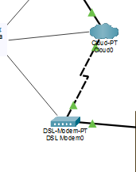
Figure 1Conect Cloud To DSL Modem
- Connect DSL Modem → Server and Access Points via Ethernet.
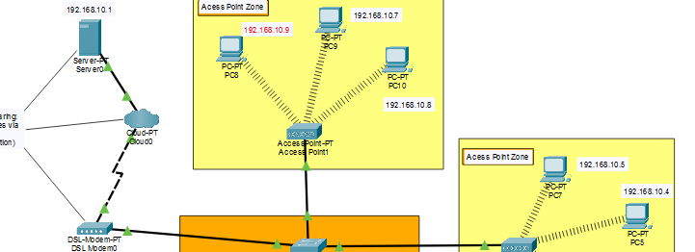
Figure 2DSL Modem connect to access point
- Assign Server0 static IP (192.168.1.10) and enable DNS + DHCP.
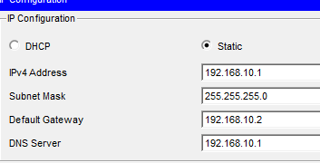
- Configure Access Points with SSID Company_WiFi and WPA2 security.
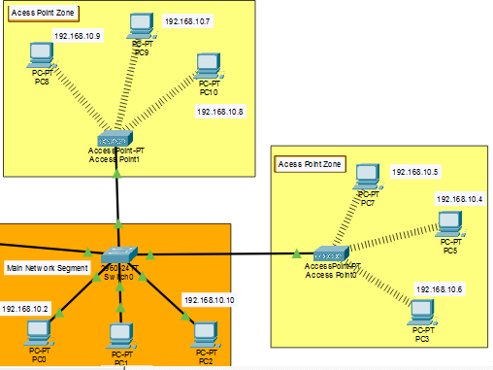
- Set all PCs to DHCP mode for automatic IP assignment.
- Use Simulation Mode to test communication.
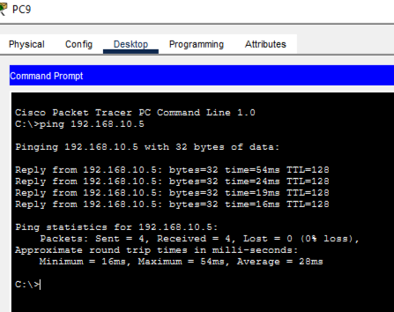

9. Simulation & Testing
Test 1 – Local Access:
PC0 successfully pinged Server0 and accessed its hosted website.
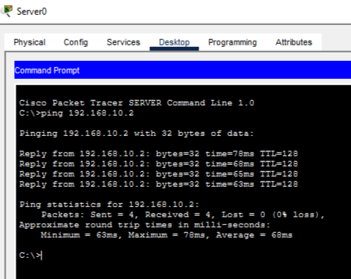
Figure 3ping server 0 to Pc 0
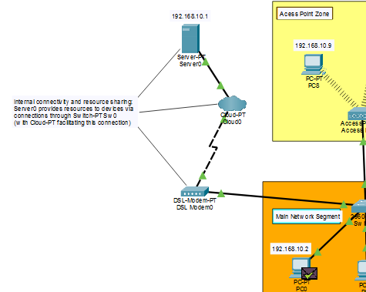
Figure 4Travel Packet PC0 to Server 0
Test 2 – Wireless Communication:
PC7 (Wi-Fi) communicated with PC2 (wired)—WLAN and LAN integration successful.
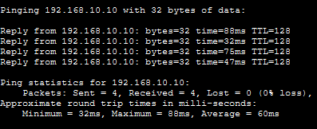
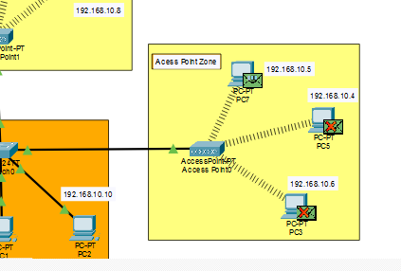
Figure 5Seccesfuly DELIVER the packet on PC7 to PC2

10. Results & Discussion
The hybrid cloud network performed exactly as intended. All devices achieved:
- LAN communication
- WLAN communication
- Cloud connectivity
The topology demonstrates an efficient, scalable design suitable for small to medium-scale organizations.
- 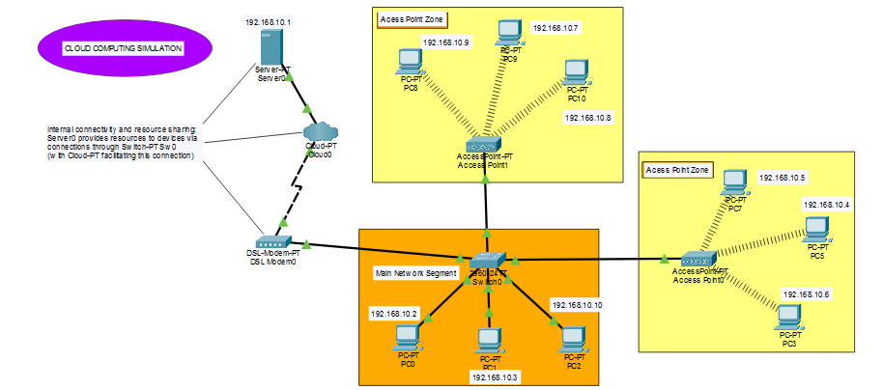
Figure 6Cloud Computing Network

11. Conclusion

This project successfully achieved the simulation of a hybrid cloud network infrastructure using Cisco Packet Tracer. The network provided seamless connectivity between local devices and cloud services. All tests passed, proving the effectiveness and practicality of the design.

12. Future Improvements
- Add a dedicated firewall for enterprise-level security.
- Implement a cloud backup server for redundancy.
- Configure a VPN for remote secure access.
- Include IoT devices to convert the network into a smart office model.

13. GitHub Upload (Mandatory)
- Upload:
Packet Tracer (.pkt) file

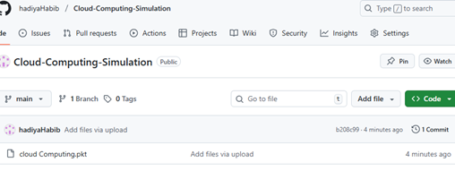
README.md describing project steps
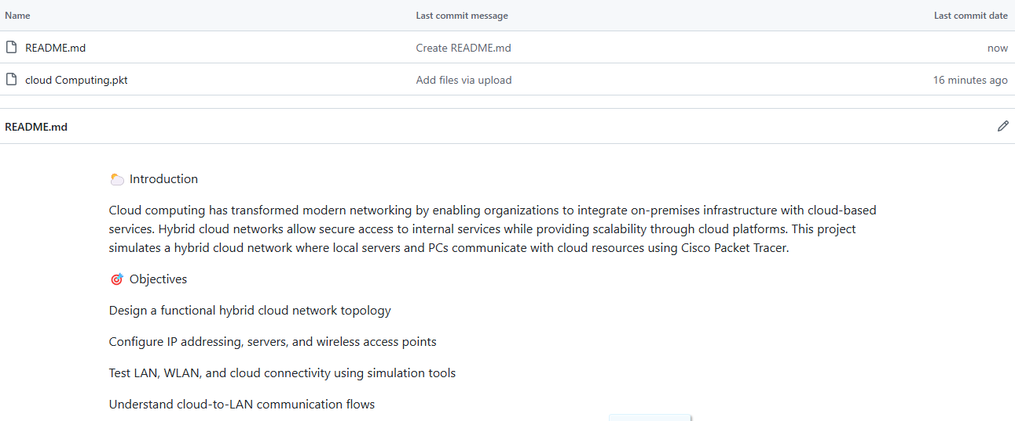
GitHub Link:hadiyaHabib/Cloud-Computing-Simulation: Cloud Computing project with simulation files

